Matthew Tran
Network Reconnaissance and Service Enumeration Using Kali Linux

In this lab, I performed reconnaissance and enumeration on a target network using Kali Linux. The purpose of this lab was to find active hosts, identify open ports, and determine what services and versions were running on those systems. By completing these tasks, I learned how attackers and security professionals gather information before attempting any exploitation.
Tools used:

- Kali Linux
- Nmap
- Netcat
- DirBuster
- Web

Task 1) Discovering Active Hosts on the Network

- Logged into the Cyber Range platform and launched the Cyber Basics environment.

- Logged into the Kali Linux system using the provided credentials.

- Opened a terminal window to run network scanning commands.

- Typed the following command to view the network routing information: route

- Identified the default gateway and determined the network range assigned to the system.

- Noted the network ID as 10.1.160.0, which was needed to properly scan the network.

- Ran an Nmap scan against the full network range to discover active hosts by typing: nmap 10.1.160.0/20

- Waited for the scan to complete and reviewed the output.

- Recorded at least four active IP addresses found during the scan.

- Observed which ports were open on each discovered host.
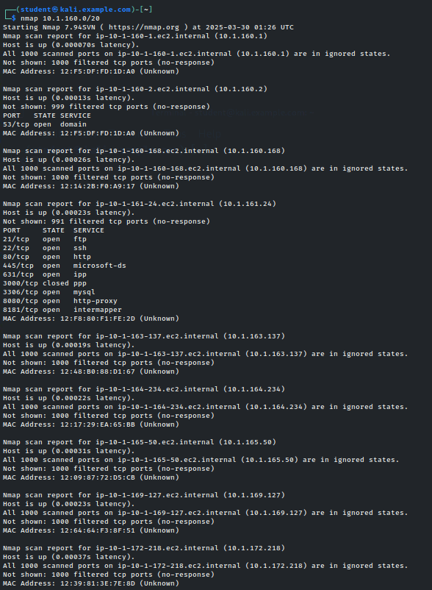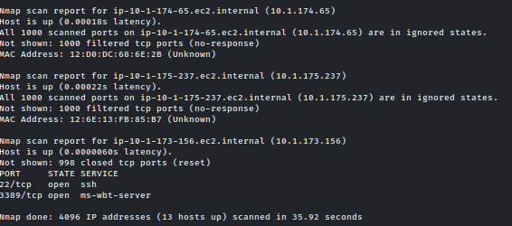
Nmap was used to scan the network in order to find active hosts and identify which ports were open on each system. During the scan, Nmap checked common ports such as 22 (SSH) and 80 (HTTP) to determine whether they were open, closed, or filtered. It also provided information about the services and versions running on those ports, which helps identify potential security weaknesses.

Task 2) Saving Nmap Scan Results to a File

- Re-ran the same Nmap scan to capture the results for documentation purposes.

- Saved the scan output to a file in the home directory by typing: nmap 10.1.160.0/20 > ~/nmap_output

- Verified that the file was created successfully.

- Displayed the contents of the file by typing: cat ~/nmap_output

- Reviewed the saved output to confirm all scan results were recorded.
Saving the scan results made it possible to review the information without running the scan again. This is helpful for reporting and comparing results later.

Task 3) Selecting a Target Host for Enumeration

- Reviewed the saved Nmap scan results.

- Looked for a host that had multiple open ports, including ports 22, 80, 139, and 445.

- Identified 10.1.161.24 as the target host.

- Recorded the target IP address for use in the remaining tasks.

- Confirmed that the open ports indicated SSH, HTTP, and SMB services.

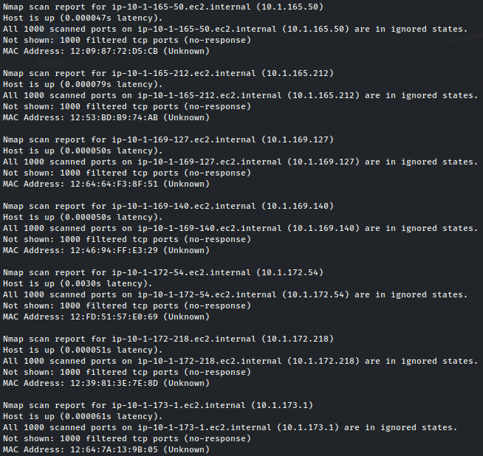
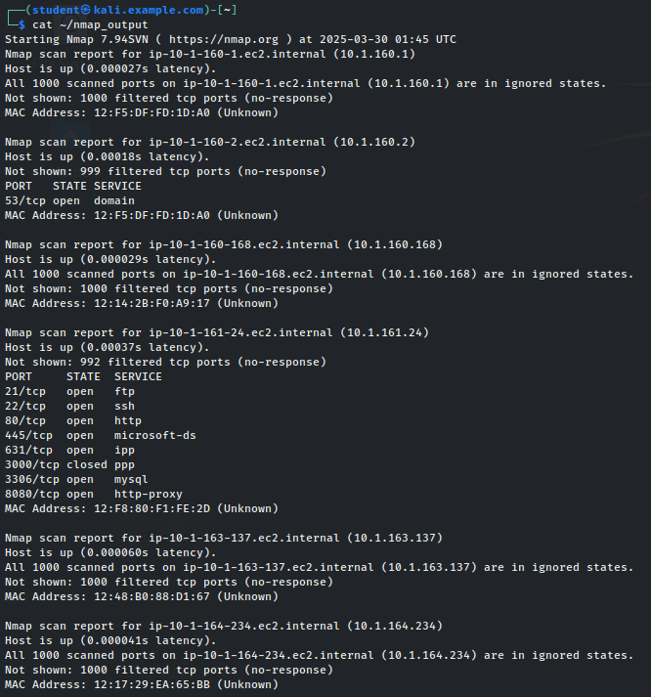

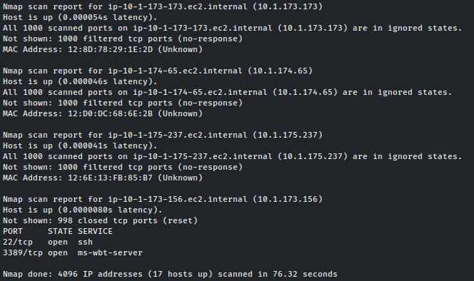
Target Ip = 10.1.161.24
Picking a host with multiple open services made it more likely to find useful information during enumeration. This step was important because all the remaining tasks depended on choosing the right target system.
Task 4: Enumerating the Web Server (Port 80)

- Opened a web browser on the Kali Linux system.

- Disabled proxy settings to allow direct access to local web servers.

- Entered the target IP address into the browser address bar.

- Viewed the web page hosted on the target system.

- Noted the Apache web server version displayed on the page.

- Searched for known vulnerabilities related to the identified Apache version

The web server revealed useful version information that could be used to identify security flaws. Web services are common targets because outdated versions often contain known vulnerabilities.
CVE-2015-5600 (7.8 CVSS): Local privilege escalation
CVE-2015-6565 (7.8 CVSS): Privilege escalation via PAM
CVE-2014-2532 (5.0 CVSS): Weak Diffie-Hellman key exchange

No direct remote code execution (RCE) vulnerabilities
Mostly local privilege escalations (require existing access)

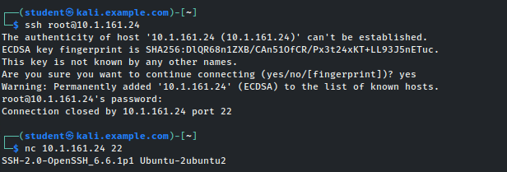
Weak key exchange could enable MITM attacks

Task 5: Discovering Hidden Web Directories Using DirBuster
Opened a terminal window on the Kali Linux system.

Launched DirBuster by typing:

dirbuster &

Entered the target URL using the target IP address.

Selected the medium directory wordlist provided by DirBuster.

Started the directory scan.

Waited for the scan to identify hidden directories and files.

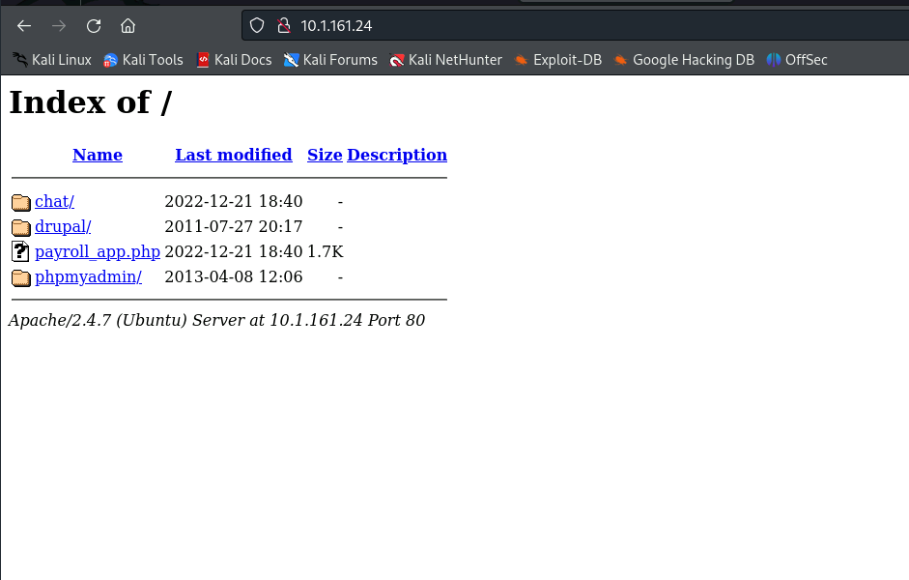
Reviewed the results list after the scan completed. Q4 (20pts): attach a screenshot of successfully showing version of Apache Web Server and using online source, what are the vulnerabilities associated with that particular version.

CVE-2017-3167 (CVSS 9.8)
Explain: Remote code execution via mod_ssl
Impact: Attackers can execute arbitrary code as root
Fix: Upgrade to Apache ≥2.4.26

CVE-2017-3169 (CVSS 8.1)
Explain: Buffer overflow in ap_pregsub()
Impact: Crash or RCE via crafted .htaccess files

CVE-2015-0253 (CVSS 7.5)
Explain: Memory corruption in mod_auth_digest
Impact: Remote crashes or potential RCE

Task 6: Web Server directory enumeration using Dirbuster

- Opened a terminal window on the Kali Linux system.

- Launched DirBuster by typing: dirbuster &

- Entered the target URL using the target IP address.

- Selected the medium directory wordlist provided by DirBuster.

- Started the directory scan.

- Waited for the scan to identify hidden directories and files.

- Reviewed the results list after the scan completed.

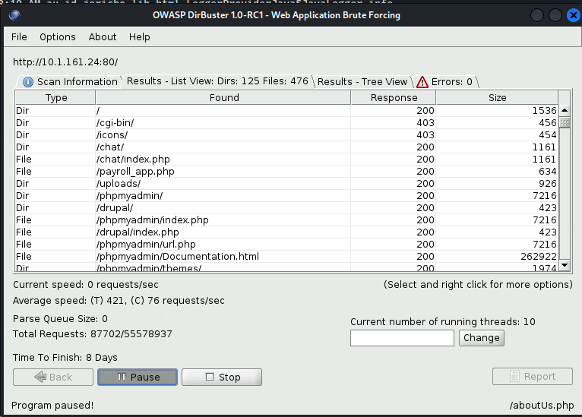
/chat/
/drupal/
/phpmyadmin/
/payroll_app.php
There was way more to be found but the files would’ve taken too much time to finish.

DirBuster found directories that were not visible through normal browsing. Hidden directories can sometimes expose sensitive pages or misconfigurations, making this step valuable during enumeration.

Task 7: Enumerating SMB Services Using Nmap Scripts
- Opened a terminal window on the Kali Linux system.

- Ran an Nmap scan using an SMB discovery script by typing:

- nmap --script smb-os-discovery.nse 10.1.161.24

- Reviewed the output to identify the Samba version running on the target.

- Recorded the discovered version information.

- Checked for known vulnerabilities related to the identified Samba version.
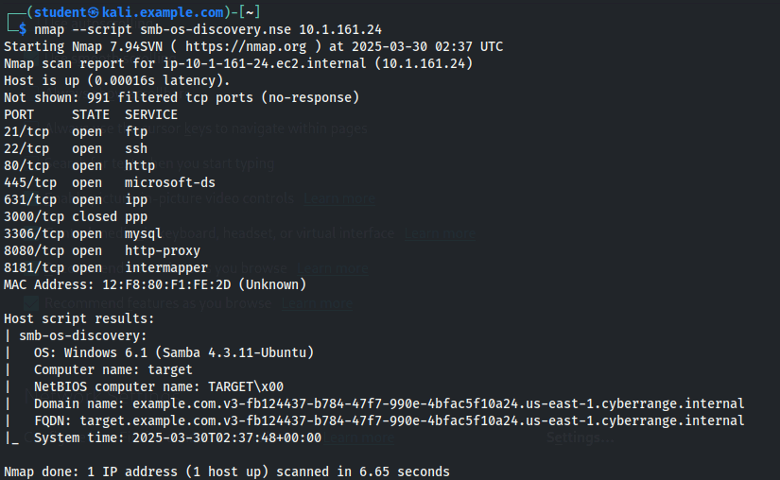

CVE-2017-7494 RCE via writable shares
CVE-2016-2118 MITM attacks
CVE-2021-44142 RCE (if vfs_fruit enabled)
The SMB enumeration revealed detailed information about the target system. Some Samba versions are known to have serious vulnerabilities, which makes SMB an important service to examine during reconnaissance.
Skills Learned

- Finding active systems and the network range they belong to

- Scanning a network to see which ports and services are open

- Saving scan results so they can be reviewed later

- Choosing the right system to focus on for deeper testing

- Checking SSH, web, and SMB services for useful information

- Noting service versions to see if they might be vulnerable

- Understanding why gathering information is important before attacking a system

